**COMPUTER PROGRAMMING**

**(CSL-113)**

**“PROJECT REPORT”**



**DEPARTMENT OF COMPUTER SCIENCE**

BAHRIA UNIVERSITY, KARACHI, PAKISTAN

**Project Title:**

***‘HOTEL MANAGEMENT SYSTEM’***

**MADE BY:**

**ANAS AHMED QURESHI (02-134212-042)**

**Submitted to:**

**TOOBA ZAHID**

* ***INTRODUCTION:***

The main purpose or objective of this project on Hotel Management System is to manage the details of rooms, customers, booking and other services of the hotel. This project helps to reduce the work manually and this application is very useful even you are a distance away or far from that place. This is very useful for the customers for booking or reserve the hotel rooms for their work or for any other purpose. This will help the customers in booking because it is all a computer system in which there will be no error as compare to human there as many errors occur like balancing time, budget, in maintaining records keeping records of all customers that what they will need and so on. This program is very user friendly and very simple because I’ve covered all the topics of my course in a C++ language.

* ***FLOWCHART:***

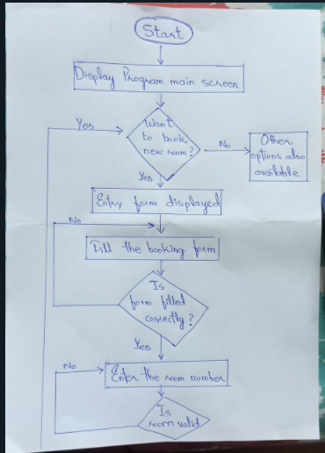

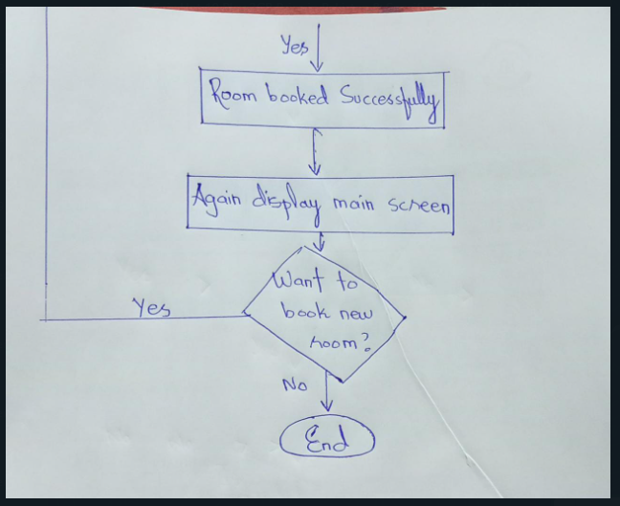

* ***SCREEN SHOTS:***

**(MAIN OUTPUT)**

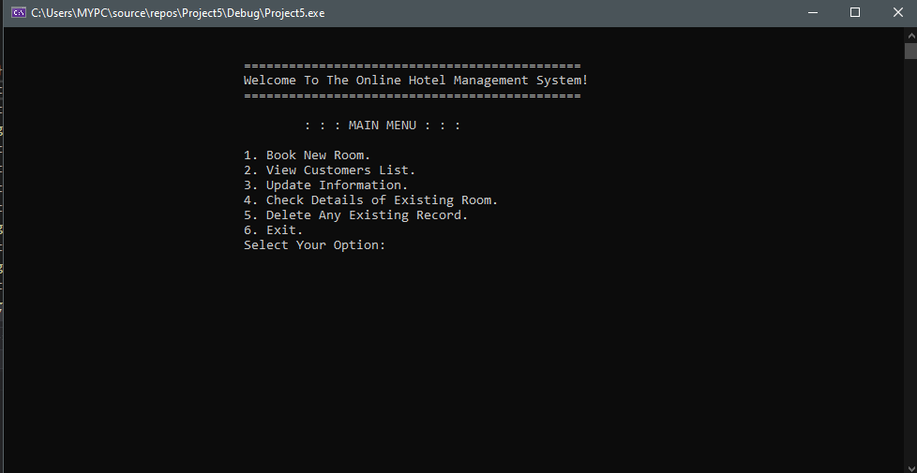

**(BOOKING ROOM)**

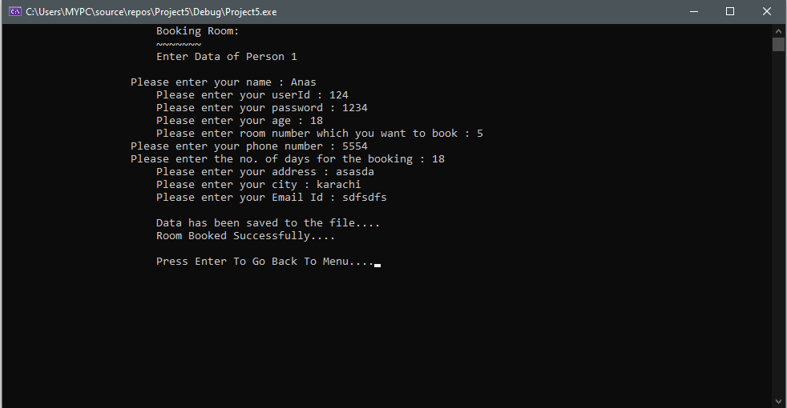

**(BOOKED CUSTOMER’S LIST)**

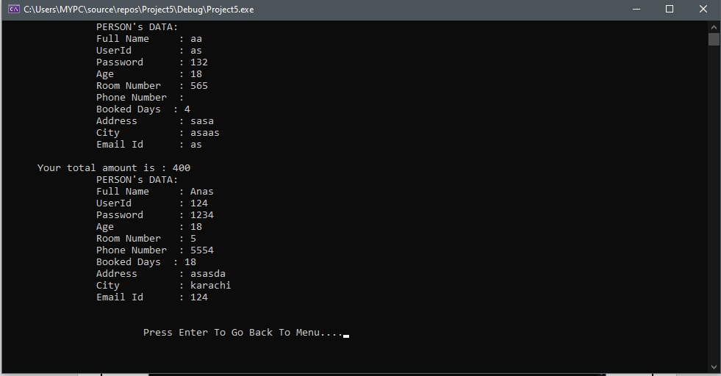

**(CHECK EXISTING ROOM)**

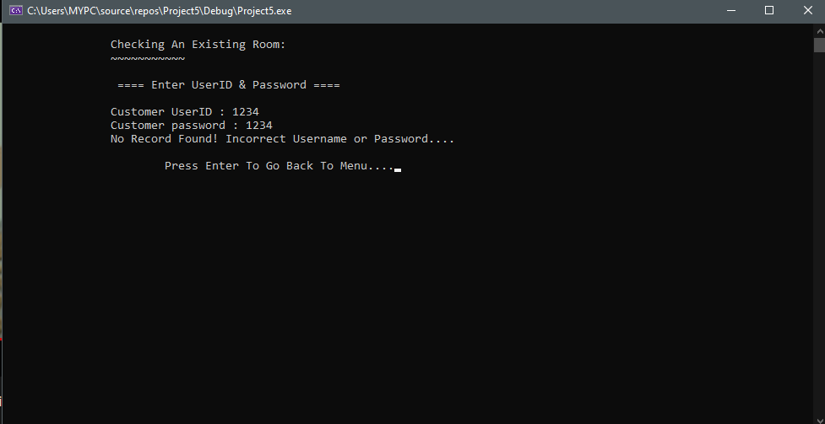

**(DELETE EXISTING RECORD)**

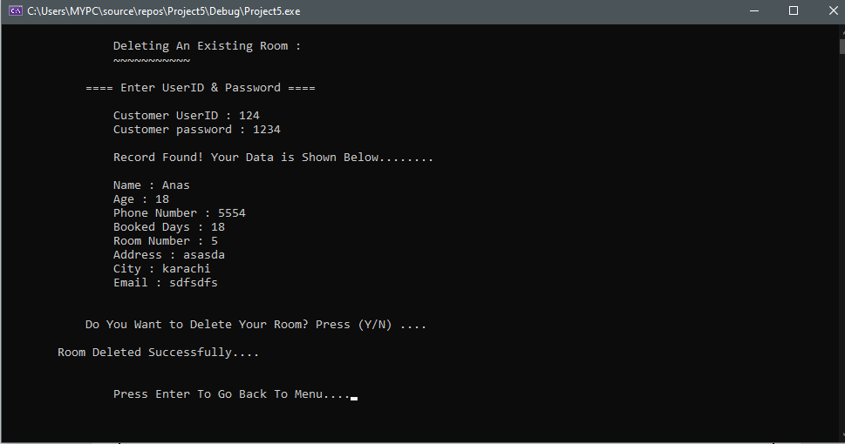

**(EXIT)**

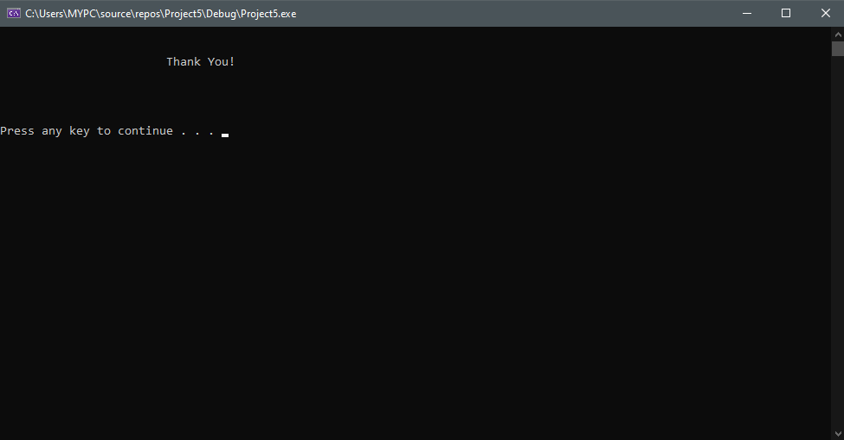

* ***PROGRAM DESCRIPTION:***

Simple Hotel Management System is based on the concept of managing the hotel room’s bookings. In this system, there are no login features. The user can manage room bookings, customer records, view total allotted rooms, edit records. This mini project contains limited but essential features.

Talking about the features of the Hotel Management System, the user can easily book a room by providing room number, name, address, phone number and some other details as well for the hotel booking requirements. The user can also search for the customer’s detail from their room numbers. He/she can check the total room’s allotted which shows room numbers, customer’s name, their addresses, and phone numbers. All the stored records can be modified and deleted.

So let’s talk about the program working in detail first when we enter into the program then you will see a main screen of hotel management system main menu in which there are several options like you can book new room, view booked customers list, view allotted rooms, delete specific options like things and at the final you can exit from the program. So, this program is very simple and very short because as well as I covered my course all topics in this program.

In this program I uses loops, structures, switch and if or else statements, arrays, functions. I made this program very user friendly and very most understandable in a C++ language.

* ***CONCLUSION:***

So, at the end ill repeat that this program is very user friendly for the users and it is very simple program. The hotel management system is not a simple project like you can add more functions and made this program very modernize by adding more things which can be seen in hotel management program. In C++ language in which I’ve studied the topic I tried my best to cover all of them and made this program more valuable and do give my best for this program and I repeat this program is very simple and very user friendly.

**X--------X**